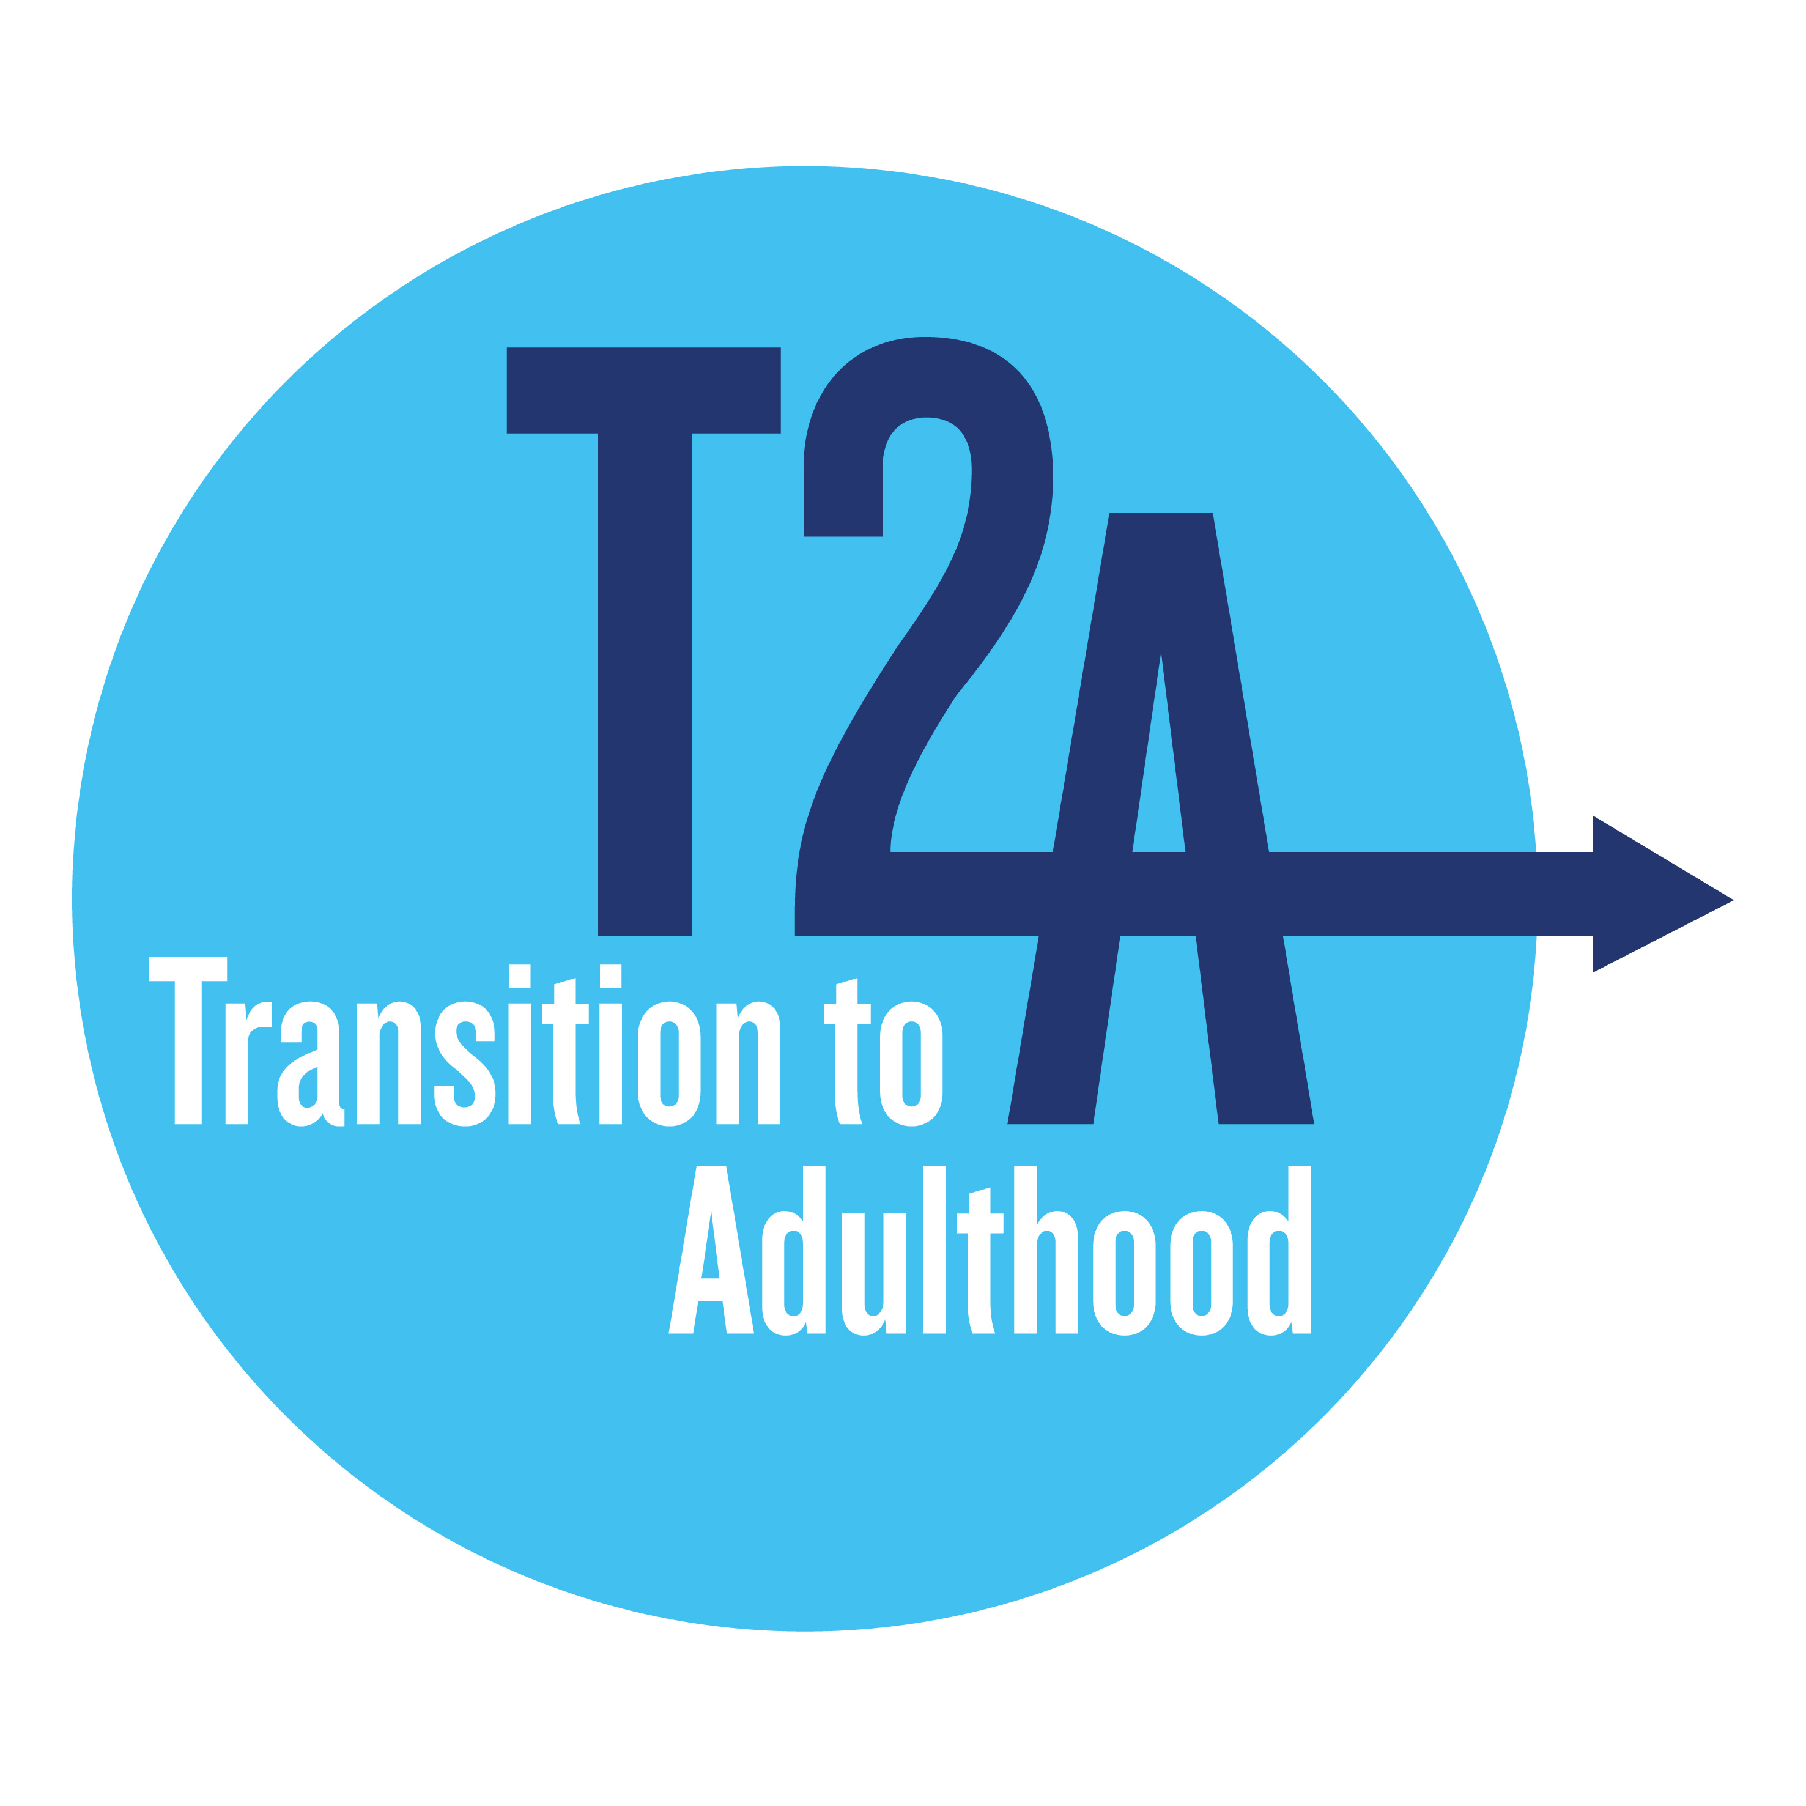

**Transition to Adulthood Alliance response to consultation on the Prison Strategy White Paper**

**February 2022**

The Transition to Adulthood (T2A) Alliance evidences and promotes effective approaches for young adults (18-25) throughout the criminal justice system (CJS). It is an alliance of 15 leading criminal justice, health and youth organisations (listed on our website [www.T2A.org.uk](http://www.T2A.org.uk)). Convened and funded by the Barrow Cadbury Trust, it has been making the case for a distinct approach for young adults in the criminal justice system for over a decade. Based on the clear neuroscientific evidence that the brain is not fully formed until at least the mid-20s, there is ample opportunity during this phase of life to intervene and improve life chances and reduce crime.

**Chapter One – A Roadmap to Building the Future Prison Estate**

***Do you agree that these are the right long-term ambitions for the prison estate?***

T2A welcomes the government’s development of a strategy for the prison estate but we have concerns about the impact of prior policy decisions which have led to a rising prison population and insufficient government funding. As a result, the government should not underestimate the challenge it faces in implementing the strategic vision set out in the Prison Strategy White Paper.

As part of the Ministry of Justice’s long-term ambition for prisons, T2A would like to see a clear public statement setting out its policy on young adults aged 18 to 25. As the prison population expands, working effectively with this cohort as they serve longer sentences, (including some who will spend their entire formative period of young adulthood in custody), will be of paramount importance in managing projected growth of the prison population and getting good outcomes for individuals and society. We welcome the government's aspiration to design regimes which meet the needs of the diverse prison population. Investment in building modern prisons is an opportunity to get things right in terms of policy for young adults and to develop and deliver developmentally appropriate prison accommodation, staffing models and regimes which provide the best conditions to work effectively with this cohort to support rehabilitation and cut crime. We also welcome a renewed emphasis on the use of data but note that this is undermined by young adults not being distinguished as a cohort in routine data collection to support age-appropriate policy decisions.

We welcome the focus on neurodiversity. The high prevalence of various different neurodisabilities amongst young adults in the criminal justice system highlights the importance of understanding the potential complex mix of co-morbidities and resulting needs that might be present in individual cases. T2A is concerned that the lack of proper assessments in the current system means that where low maturity is identified by HMPPS, there is no opportunity to assess whether this relates to typical young adult development or atypical development which may be related to other forms of neurodiversity. Research on maturational development shows that temperance and impulse control located in the frontal lobes at the front of the brain, are among the last areas of the brain to develop fully, often as late in life as the mid-twenties[1]. One example of possible co-morbidity is traumatic brain injury (TBI). An injury to this part of the brain during its development can result in long-term problems with impulse control and decision-making, both of which are factors associated with anti-social and violent behaviour. Consequently, while those without a traumatic brain injury are likely to grow out of immature and antisocial behaviour by their mid-twenties, those with TBI are likely to continue to grapple with these issues throughout young adulthood and beyond. It is critical that the relationship between maturity and different forms of neurodiversity are better understood.

We also welcome the focus on safe transitions into the adult estate and the government's plans for the HMP Deerbolt transitions unit to be a pilot which would be rolled out across the estate should it be found to be effective. In order to do so, the impact of the pilot unit should be independently evaluated. However, we are concerned that the strategy overlooks a long-standing wider issue about accommodation for young adults, including the undermining of the status of the sentence to ‘Detention in a Young Offender Institution (DYOI) and the generic accommodation in which young adults serving such a sentence are now held. The current use of parts of the estate which were previously ring-fenced for young adults but have been put to general use renders this specialist sentence inoperable,. This has undermined the legislative intent of there being a dedicated sentence for young adults which was designed to meet their particular needs. The Justice Select Committee recommended retaining the DYOI sentence and increasing the age eligibility to age 25. T2A strongly supports this view and believes it to be in the best interests both of young adults and of society as a whole. We are surprised that this issue has been omitted from consideration in the Equality Assessment accompanying the White Paper because distinct provision is made in legislation which it is not possible to implement in reality.

The new strategy and prison building programme provides further opportunity for piloting and evaluating distinct approaches towards young adults in custody to strengthen the evidence base on how best to meet the needs of this cohort, as recommended by the Justice Select Committee in 2016. We would like to see the Ministry of Justice being bold and co-creating accommodation models and regimes with young adults and their advocates and ongoing and more ambitious testing of different options to determine which provide the best short- medium- and long-term outcomes. It goes without saying that funding independent evaluation of promising approaches and implementing proven effective practice nationwide is of vital importance if we are to break the cycle of offending and reoffending.

We have major concerns that where young adults have been referred to in the White Paper, the government has placed its emphasis on them being "amongst the most violent and disruptive" in the prison estate, rather than on their potential for change and reform. T2A’s evidence demonstrates the importance of young adults being treated in a distinct manner which is consistent with their developmental status. Given that this has never been a strong feature of the prison approach, even where there were distinct institutions, it is important for the government to understand the extent to which existing policies and practices exacerbates these challenges and what steps can be taken to ameliorate this. By positioning young adults primarily as trouble-makers risks overlooking the major opportunities that exist for reform amongst this cohort while their adult brains and identities are still developing. We are therefore disappointed not to see reference as part of the strategic approach for the future of the prison estate to other (independently evaluated) pilots of different types of accommodation for young adults, for example, the dedicated wing proposed at HMP Nottingham and that previously proposed at HMP Bedford. Good examples of a young-adult centred approach also exist in other jurisdictions and we would like to see evidence of learning from these.

The Prison Strategy White Paper has an insufficient consideration of Black, Asian and Minority Ethnic (BAME) overrepresentation in custody and prison-related outcomes. A strong emphasis should be placed on significantly increasing dedicated resources for community engagement to facilitate the development of culturally informed partnership working models in prisons. This should ensure effective engagement, at strategic and delivery levels, for voluntary sector organisations with relevant cultural knowledge that can demonstrably meet the needs of 18-25-year-old BAME people in prison.

T2A welcomes the acknowledgement in the White Paper of the geographic disparities in the levels of reoffending across the country and the commitment to getting resettlement right as part of the work to ‘level up’ all areas of the country by reducing reoffending. As part of such a strategic approach it should be acknowledged that there are also geographic disparities in sentencing and custodial outcomes for different cohorts, including young adults.

We welcome the government's intention to scale up the use of digital, data and technology. The ambitions for digital innovation in prisons is particularly welcome and note the particular benefits young adults can gain by engaging in learning opportunities appropriate to their age. We have already noted the need for segmentation of data to enable the needs and outcomes of the young adult cohort aged 18-25 to be properly delineated, which is not currently routinely possible and if not recognised and addressed may undermine governors' capacity to develop distinct interventions and regimes for this group. The opportunity to join up data sets to determine long-term outcomes of young adults held in prison vs other sentencing options, including the development of evidence on the impact of longer prison sentences (which the government is introducing in the Police, Crime, Sentencing and Courts Bill (PCSC)) should be undertaken to ascertain an evidence base on the sentencing options that reduce reoffending and cut crime.

**Chapter Two – Tackling Violence and Reducing Harm**

***Do you agree these are the guiding principles around which the future regime should be designed?***

We welcome the development of an Enhanced Support Service in prisons where violence is most prevalent. Young adults would benefit in particular from this provision and HMPPS may wish to target that cohort initially. During this period of young adult development, the formation of positive identities is of paramount importance and HMPPS could usefully explore how best to imbue a culture and relationships that foster that. This should include, but not be limited to implementing constructive plans for managing remanded young adults and those subject to the parole process who are in custody during a formative part of their lives. This should also include exploring how periods in custody during young adulthood result in limited opportunities for typical life experiences and what long term impact this has on their maturation. T2A is concerned that long custodial sentences during this important phase of development risks compounding the negative characteristic behavioural features of this cohort and may further undermine individuals’ emotional capacity to engage effectively and further hinder their life chances.

The Justice Select Committee recommended that young adults be provided with enhanced support in its report in 2016. While it was mooted that some young adults would be given enhanced Offender Management in Custody (OMiC) support, we note that it is not yet clear how that model is currently embedding due to challenges in implementation and operation during the pandemic and in the face of staffing shortages. We are interested in how the Enhanced Support Service will differ from enhanced OMiC and we are keen to understand more about how young adults are currently benefiting from this service. It is important that the existing policy priority to implement and embed OMiC is not substituted for this new model, notwithstanding its potential benefits.

T2A welcomes the recognition of the importance of ‘hope’. T2A is aware that some children and young adults have been sentenced to very long sentences with little opportunity to benefit from rehabilitation programmes. It is of concern that no mention is made of the Long Term High Security Estate and the young adults held there despite the likely significant increase in that population due to sentencing provisions in the PCSC Bill.

***Do you agree with our long-term priorities for making prisons safer?***

T2A welcomes the improvements to the adjudications system and the recognition that existing disposals are ineffective. Nevertheless, the assumption is made that punishment should be the primary mechanism for achieving change despite the acknowledgement that rehabilitative sanctions can be more effective. It is important to understand the reasons underlying the behaviour and taking steps to address those behaviours should be at the forefront of the adjudications processes.

The government appears to have adopted a narrow perspective solely focused on cracking down on crime in prisons. To provide safety in prisons there are a wide range of service providers that need access to the estate. The importance of local relationships, not only with probation services, but also with local authorities including housing and social care and the third sector will enable support to be provided in custody and enable links to support services on release. T2A is particularly concerned about what lengthier sentences stemming from the Police, Courts, Sentencing and Crime Bill will mean for the resettlement prospects of those care leavers who will no longer be eligible for support from local authorities on release due to longer sentences, removing the opportunity for them to benefit from their statutory entitlement.

***Where can we go further?***

Facilitating change in individuals is more than just about delivering interventions; it is also about developing young adults to reach their potential so they are able to develop pro-social identities once they reach full maturation. We are disappointed not to see any mention of the overarching Young Adults strategy and opportunities stemming from the HMPPS Young Adult Programme. T2A hopes that the absence from the strategy is not indicative of a dilution of commitment to developing new strategic approaches to young adults. We firmly believe that the momentum created by the HMPPS Young Adult Programme—a welcome but relatively short-term project—should be maintained as part of the MoJ’s future strategic approach to prisons. Embedding a distinct approach and ensuring that the prison estate is fit for purpose to provide developmentally appropriate regimes and interventions will require a sustained resource commitment which is not project based.

In particular, T2A is keen to ensure that the longer-term strategic commitment to young adults is aligned with other programmes which are strategic priorities for example the development of future prison regimes.

**Chapter Three – The Role of Prisons and Probation in Cutting Crime and Protecting the Public**

***Do you agree with the ‘guiding principles’ and priority outcomes and areas of focus we have identified for developing the Resettlement Passports?***

There is a risk that placing emphasis on resettlement passports will overlook real logistical issues which young adults face with resettlement and compliance with post-release supervision. In T2A's experience, resettlement passports are one relatively small aspect of existing challenges. For example, for young adults there are long-standing structural issues which hinder the prospects of rehabilitation, including the criminal records regime and the lower minimum wage and lesser entitlement to housing and unemployment and other welfare benefits, all of which hinder pro-social behaviours, integration back into society and the fulfilment of potential. There are also practical issues related to meeting supervision requirements with limited resources to fund transport, both on the day of release and thereafter.

.

**Chapter Four – A New Approach to Women’s Prisons**

**Do you agree with our long-term vision for women’s prisons?**

T2A welcomes HMPPS' commitment to develop a Young Women’s Strategy and its recognition of the need for age-appropriate care for women. We consider it important that the strategy is fully integrated with other aspects of the government's strategic approach to ensure that its various priorities are complementary rather than competing.

**Chapter Five – Our People**

**Do you agree that more bespoke recruitment training will enable prison officers to better support the needs of prisoners? What other cohorts should we be focusing on and how can we do this in a manner that advances equality of opportunity for offenders with protected characteristics?**

We welcome the government's aspiration to develop tailored training for staff in working with specific cohorts. T2A remains of the view that there should be dedicated accommodation for young adults and hence dedicated staff to enable a distinct, developmentally appropriate approach. The suite of existing online training on young adults needs to be embedded in staff training. While we are delighted that it has been made available, its use and impact also needs to be monitored. We also welcome the introduction of supervision for operational staff and the government's acknowledgement of the need to support governors to develop models of reflective practice and supervision, particularly through OMiC. This is a vital aspect of embedding learning. We propose that a young adult specific practice guide is developed to facilitate effective reflective practice in working with this cohort.

Additionally, T2A would like to see long-term effective senior leadership towards young adults with the continuation of a named Director responsible for young adult services across all prisons supported by a dedicated and expert team with the capacity to implement, maintain and monitor change.

1. [The development of cognitive and emotional maturity in adolescents and its relevance in judicial contexts (scottishsentencingcouncil.org.uk)](https://www.scottishsentencingcouncil.org.uk/media/2044/20200219-ssc-cognitive-maturity-literature-review.pdf) and [Birmingham-University-Maturity-final-literature-review-report.pdf (t2a.org.uk)](https://t2a.org.uk/wp-content/uploads/2016/02/Birmingham-University-Maturity-final-literature-review-report.pdf)